1. What is the emissions per capita of Canada? **Answer: 18**

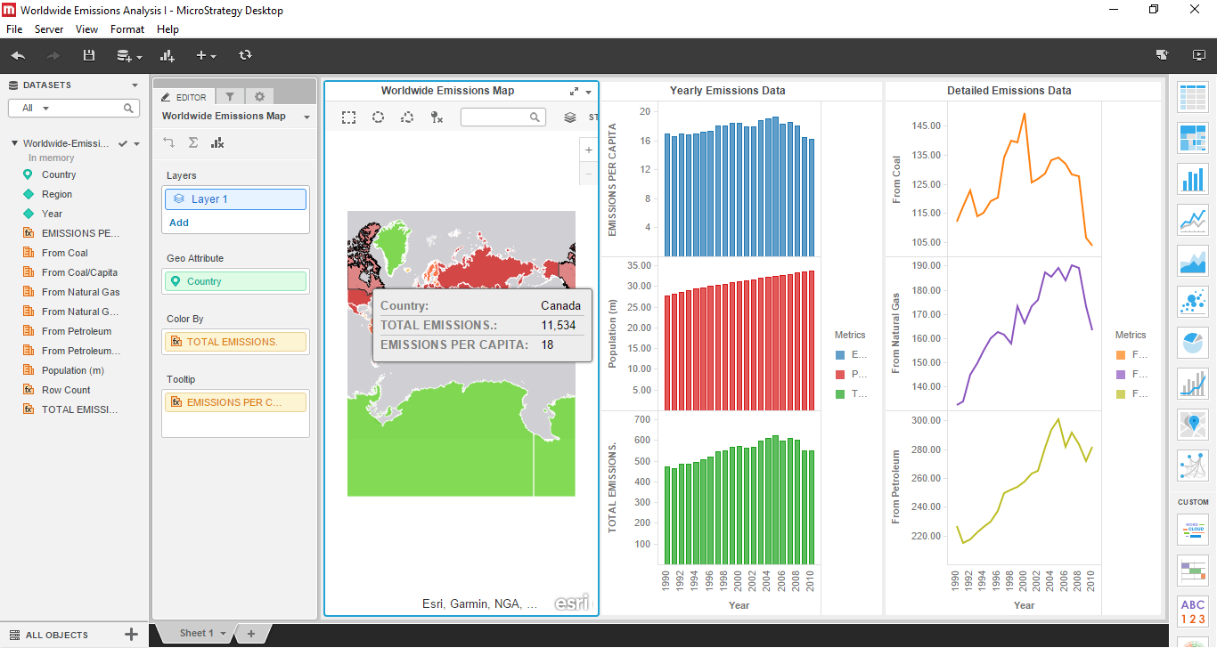

1. What is the overall trend in worldwide emissions? **Answer: Increasing as shown by the trend line on the total emission graph in the ‘yearly emissions data’ visualisation.**

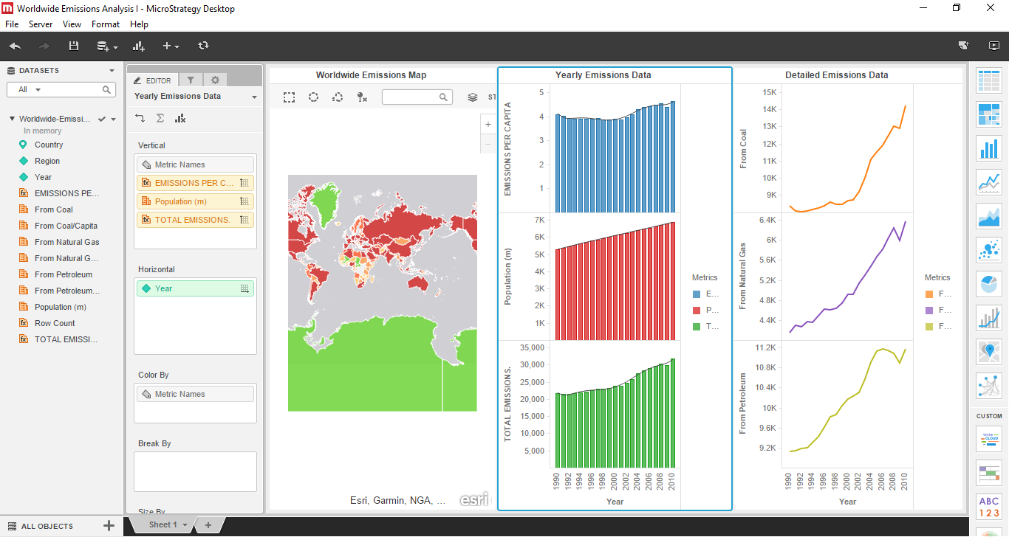

1. Notice that overall emissions declined in 2009, the only year in the total number of years surveyed that indicates emissions decreases in all three emissions sources.

Why is that? What broader socio-political context might explain this single yearly decrease?

**Answer: The introduction of a climate change policy that enforces lower emissions standards or something like a global recession causing less demand for these products.**

